Project Design Phase-II

Data Flow Diagram & User Stories

**Data Flow Diagram:**

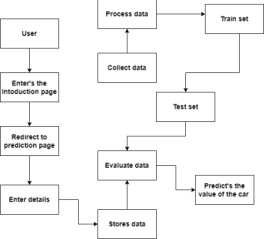

**User Stories**

|  |  |  |  |  |  |  |
| --- | --- | --- | --- | --- | --- | --- |
| **User Type** | **Functional Requirement (Epic)** | **User Story Number** | **User Story / Task** | **Acceptance criteria** | **Priority** | **Release** |
| Customer (web user) | Enters the browser | USN-1 | As a user, I can access to website using a web browser | I can enter by selecting the appropriate web link | High | Sprint-1 |
|  |  | USN-2 | As a user, I can proceed to the prediction page by selecting the check value button in the home page | I can enter into it without any acceptance | High | Sprint-1 |
| Customer (mobile user) | Enters into a mobile browser | USN-3 | As a user, I can use any of the appropriate mobile browser to enter into the website | I can enter by using an appropriate web link | Medium | Sprint-1 |
| Customer Care Executive |  |  |  |  |  |  |
| Administrator |  |  |  |  |  |  |
|  |  |  |  |  |  |  |
|  |  |  |  |  |  |  |